Bendable Snake
Tutorial by Anna Land, 2014
www.annacooks.weebly.com

Materials:
Cut pieces of fabric using the PDF pattern provided (LINK),
including a small piece of felt for the tongue
Craft eyes, or buttons, for the eyes
Poly-fill stuffing
Florist’s wire and wire cutters

Assemble the Body
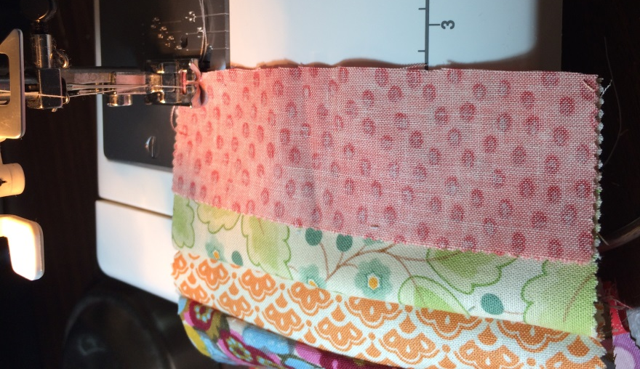 | Lay out the body pieces in your preferred order, ending with the tail piece.  Begin sewing the pieces together, right side facing, until you have a long chain of squares. End with the tail piece.  Iron your seams flat.  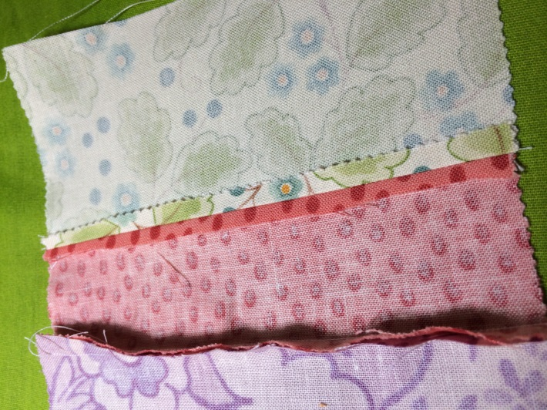
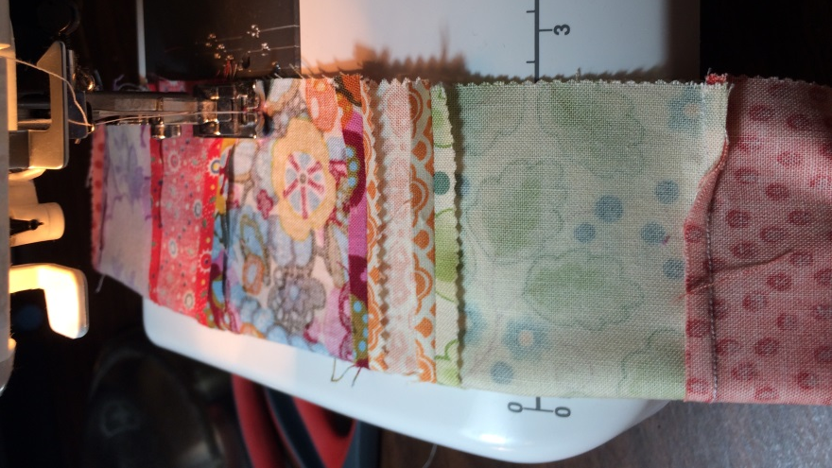 | Sew the body together along one side, right sides facing, including closing the tail.  IMPORTANT: About halfway down the body, leave a 1 ½ inch gap. It will be easier to stuff the bottom half of the snake from midway.  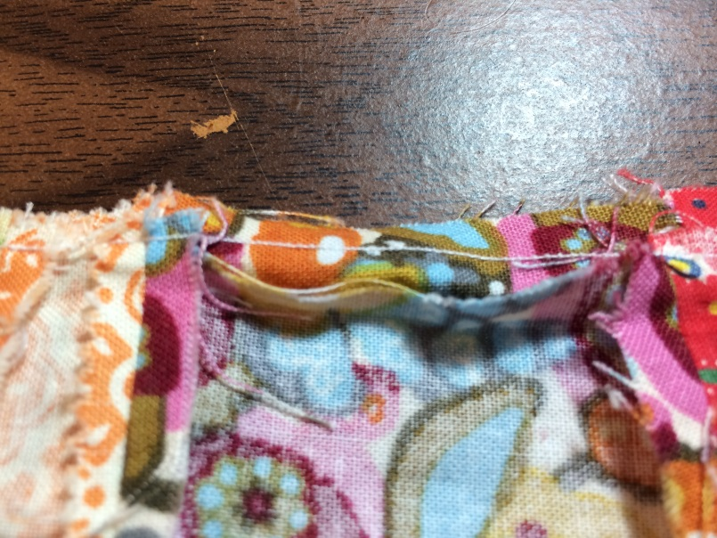

Assemble the Head
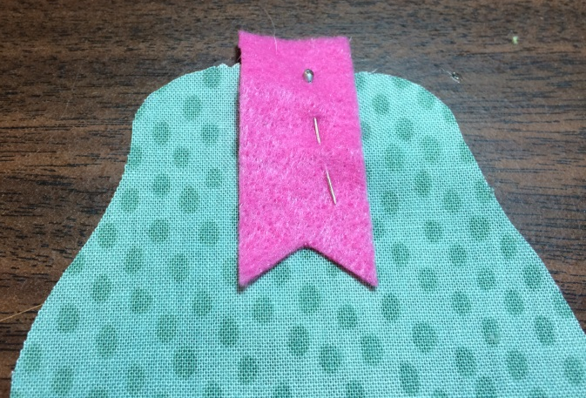  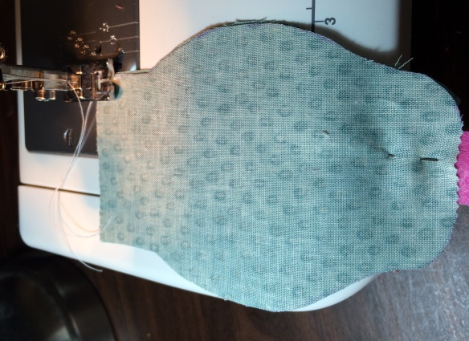 |  |  | 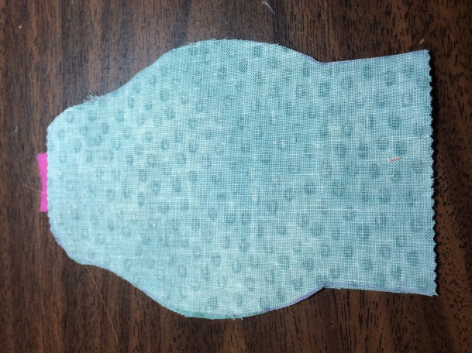  Lay one piece of the snake head right side up. Pin your pink felt tongue so that the straight edge is overlapping the snout of the snake by about a ¼ inch or so.  Then lay the other piece of the snake head right side down, so the right sides of the fabric are facing each other with the felt tongue sandwiched between.  Sew along the snake head, leaving the straight edge that will attach to the body unsewn.
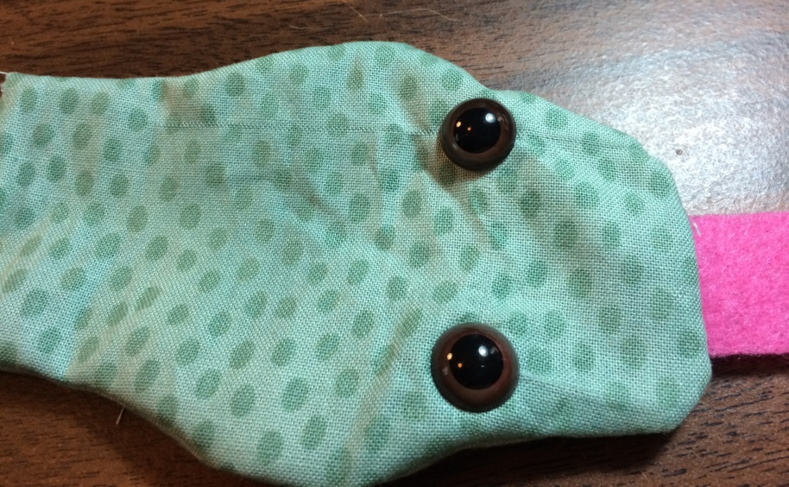 |  |  | Turn the snake head right side out, and attach eyes. You can use craft eyes like I did, or buttons. They even sell snake craft eyes if you want an even more realistic look – but they were just a little TOO realistic for my taste!  I ironed the snake head after this picture was taken.

Attach the Head and Body

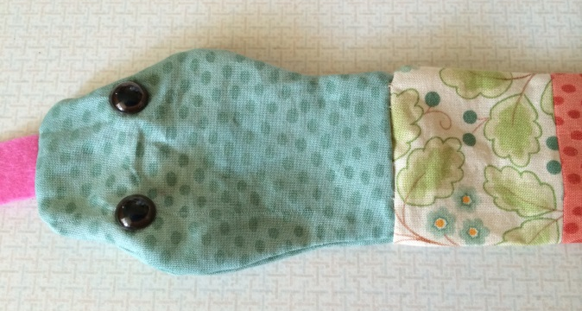 |  | Turn the snake body right side out. Sew the snake body to the TOP HALF of the head. The bottom half of the head you’ll leave unattached for now as a second stuffing point.

Stuff and Complete
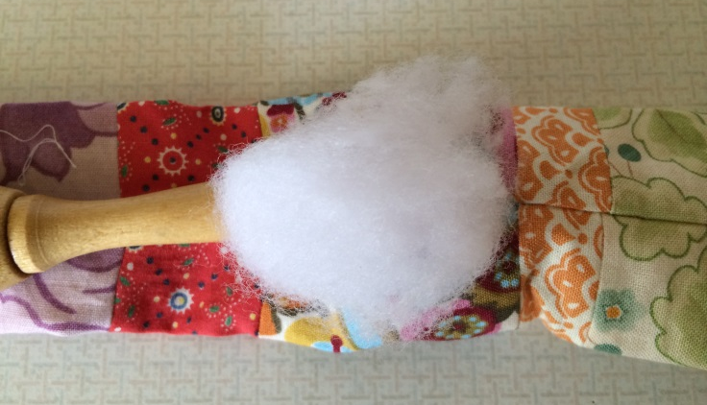 |  |  | Begin stuffing the bottom half of your snake with Poly-Fill, all the way down to the tip of the tail.  I like to roll it between my hands to make it a little more even.
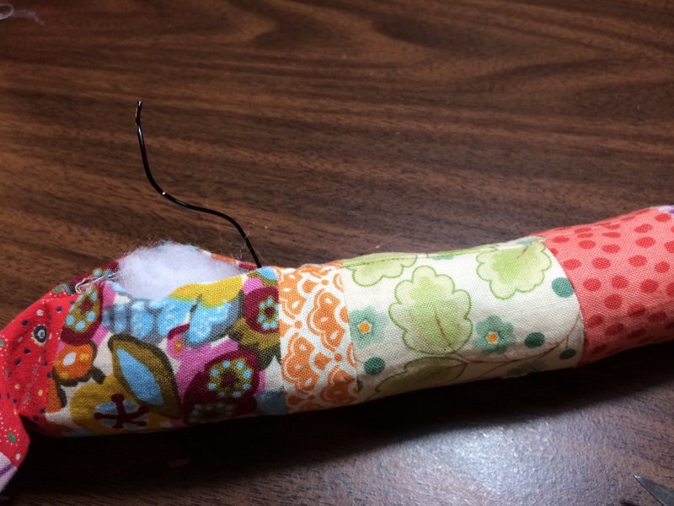 |  |  | Take a length of florist or artistic wire that is just a little longer than the bottom half of your snake. Make a loop at one end. This is the end you’ll be pushing in first, and the loop keeps it from poking out through the fabric accidentally. You’ll have to be patient, but it will snake down through the fabric.  Ladder stitch the stuffing gap closed.
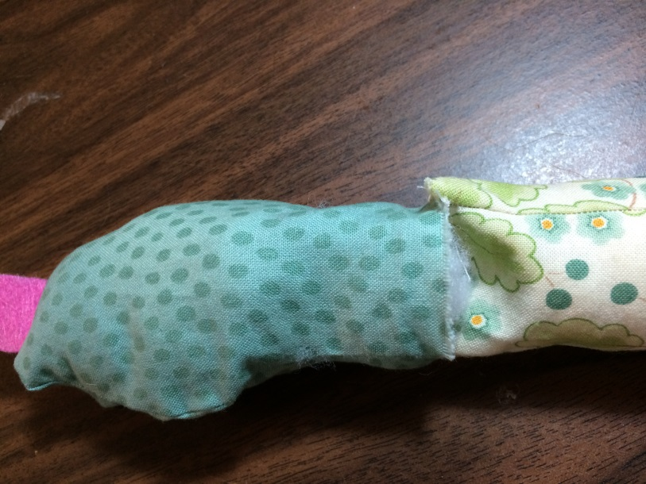 |  |  | Now you’re going to do the same thing with the head and top half of the snake. Stuff the head and top half of snake, and then push one length of florist wire into the head and body. This time you’ll make a loop on each end of the wire, since you’ll be pushing it two ways.  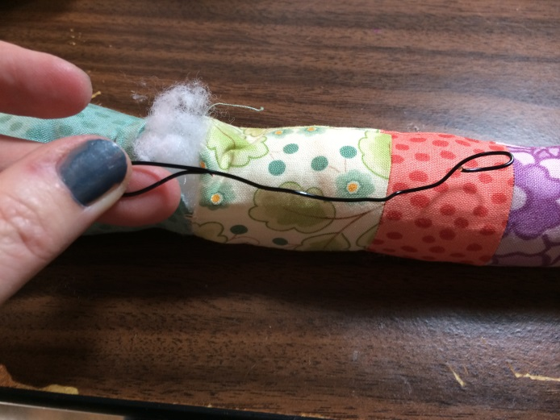

Ladder stitch the head and body together. And you’re done!

Anna xox

